**Project Title:** Hazardous area monitoring for industrial plant powered by IOT **Project Design Phase-I**

**Team ID: PNT2022TMID39342**

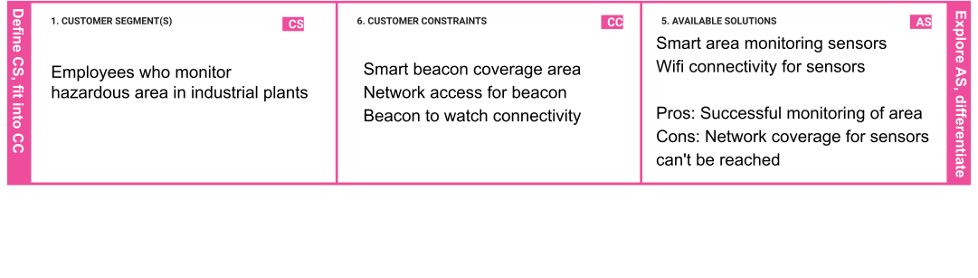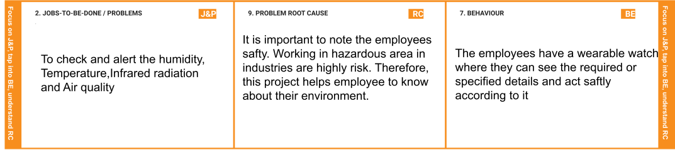

|  |  |  |  |  |  |
| --- | --- | --- | --- | --- | --- |
|  | **3. TRIGGERS**      Successful execution of our solution will make even other industry to implement this solution | **TR** | **10. YOUR SOLUTION SL**    We are going to monitor the area using suitable sensors in the beacons. We will connect our wearable to the beacons. We will send updates to online cloud from the beacon. From the cloud we will be accessing the reading and using that we will have a web page and a mobile application to display them. We will have sms service to alert abnormal readings | 1. **CHANNELS of BEHAVIOUR**   **CH**   * 1. **ONLINE**   All the informations will be stored in cloud. so the employees can see the cloud storage or mobile  application for referring the details of surroundings.     * 1. **OFFLINE**   Employees used to wear a watch which  captures the information of the surroundings. |  |
|  |
|  | |  | | | |  |

|  |  |  |  |  |
| --- | --- | --- | --- | --- |
|  | **4. EMOTIONS: BEFORE / AFTER EM**    It will be easy for employees to identify or to know about their environment |  |  |  |